PROJECT DESIGN PHASE
Solution Architecture – AI FAQ Assistant API
Date | 30TH SEPTEMBER 2026
Team ID | SWTID-2026-3072
Project Name | AI FAQ Assistant API
Maximum Marks | 4 Marks
1. Solution Architecture
The solution architecture of the AI FAQ Assistant API defines the structure and interaction of the components required to automate FAQ management and customer support. The system provides a centralized backend service that allows users to create, manage, search, and generate frequently asked questions using Artificial Intelligence.
The application is developed using Node.js and Express.js for backend processing, MongoDB for data storage, and Mongoose for database management. Google Gemini AI is integrated to generate relevant questions and answers based on user-provided topics. JWT authentication and bcrypt password hashing are used to secure user accounts and restrict access to protected API endpoints.
The architecture separates the application into different layers, including the client layer, API routing layer, authentication middleware, controller layer, database layer, and AI service layer. This modular design simplifies maintenance, improves security, and supports future enhancements.
2. Solution Architecture Diagram
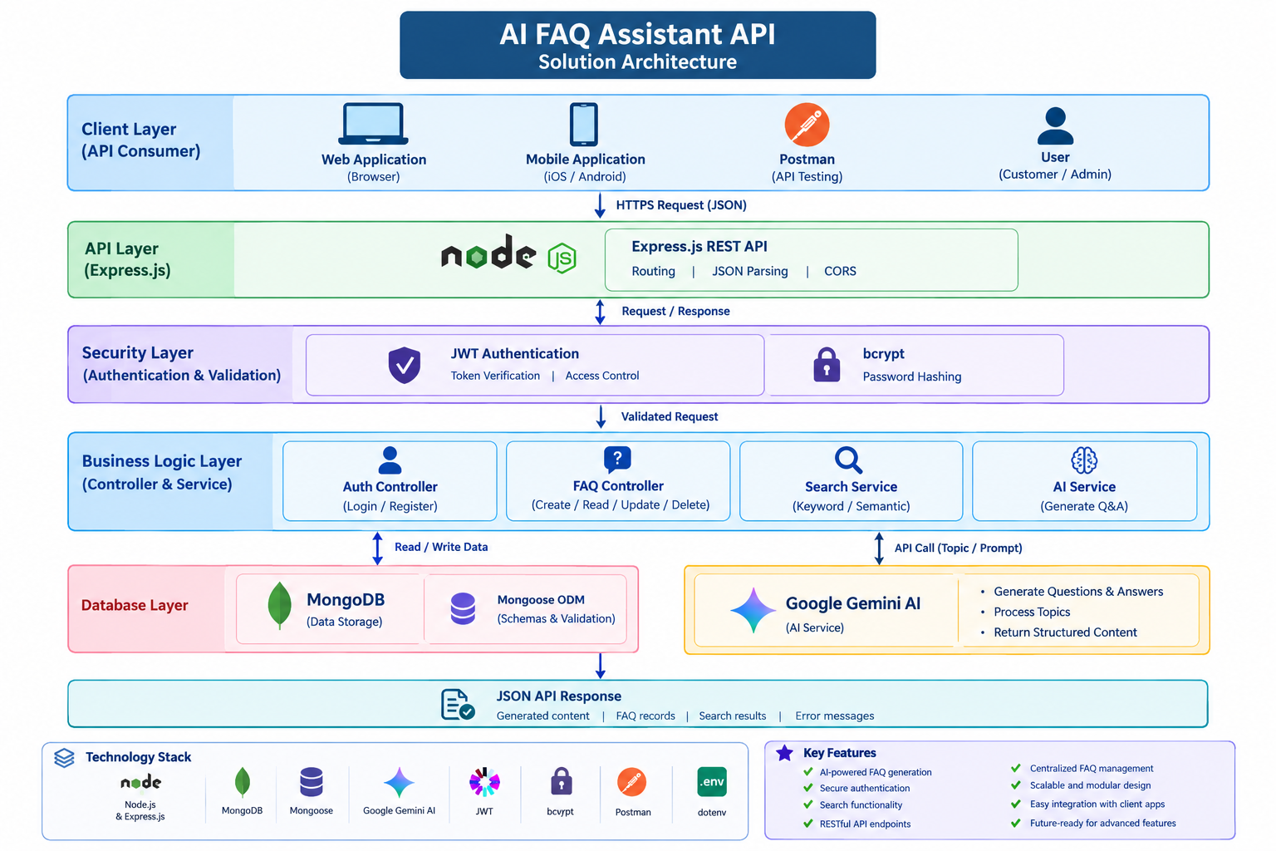
3. Architecture Components and Their Functions
Component | Description
Client Application | Sends API requests and displays the responses received from the backend.
Express.js Server | Receives HTTP requests and directs them to the appropriate API routes.
Authentication Middleware | Verifies JWT tokens and controls access to protected resources.
Controller Layer | Processes requests and coordinates FAQ, authentication, and AI operations.
MongoDB Database | Stores user information and FAQ records for future retrieval.
Mongoose ODM | Defines database schemas and validates data before storage.
Google Gemini AI | Generates FAQ questions and answers based on the topic provided by the user.
Error Handling Middleware | Handles application errors and returns structured error responses.
4. Data Flow of the Proposed Solution
- The user sends a request through Postman or a connected client application.
- The Express.js server receives the request and identifies the corresponding API endpoint.
- For protected operations, authentication middleware verifies the user's JWT token.
- The controller processes the request and performs the required validation.
- For FAQ management, the controller interacts with MongoDB through Mongoose.
- For AI-based generation, the AI service sends the given topic to Google Gemini and receives the generated content.
- The generated FAQ can be returned to the user for review and optionally saved in the database.
- The server sends the result to the client as a JSON response.
5. Technology Stack
- Backend: Node.js and Express.js
- Database: MongoDB
- Database Object Modeling: Mongoose
- Artificial Intelligence: Google Gemini API
- Authentication: JSON Web Token (JWT)
- Password Security: bcrypt
- API Testing: Postman or Thunder Client
- Configuration Management: dotenv
6. Benefits of the Solution Architecture
- Provides a centralized platform for FAQ creation and management.
- Automates FAQ generation using artificial intelligence.
- Enables quick retrieval of information through search functionality.
- Protects sensitive operations through authentication and authorization.
- Separates application components for easier development and maintenance.
- Allows integration with multiple client applications.
- Supports future expansion with semantic search, multilingual FAQs, and analytics.
Conclusion: The proposed architecture combines AI services, secure REST API endpoints, and structured database management to provide an extensible FAQ automation system. It reduces the complexity of managing frequently asked questions and establishes a foundation for intelligent customer support applications.

